clc;clear;close all;

period=24;%hours

e=0.25;

i=63.4;%degrees

omega=[90,270];%degrees

Omega=[0,45,90,135,180];%degrees

nu0=0;

deltat=5*60;%sec

mu=398600;

t0=0;

fig=1;

OmegaE = (2*pi)/(24*3600);%((23*3600)+(56*60)+4);

i=deg2rad(i);

period=period*60*60;

omega=deg2rad(omega);

Omega=deg2rad(Omega);

%Calculates the postion of each orbit every 5 minutes

a=(((period/(2*pi))^2)*mu)^(1/3);

times=t0:deltat:period;

allOrbits{1}=[];

for c=1:length(omega)

for j=1:length(Omega)

oe=[a,e,Omega(j),i,omega(c),nu0];

[r0,v0]=oe2rv_Hackbardt_Chris(oe,mu);

RandV=[];

for k=1:length(times)

t=times(k);

[r,v,E,nu] = propagateKepler_Hackbardt_Chris(r0,v0,t0,t,mu);

RandV=[RandV;r',v'];

end

allOrbits{c,j}=RandV;

end

end

%plots orbits on two plots

for m=1:length(omega)

figure(fig)

fig=fig+1;

earthSphere

title(['\omega = ',num2str(rad2deg(omega(m))),'^{o}'])

for n=1:length(Omega)

orbit=allOrbits{m,n};

hold on

plot3(orbit(:,1),orbit(:,2),orbit(:,3))

end

legend({[''],['\Omega = ',num2str(rad2deg(Omega(1))),'^{o}'],['\Omega = ',num2str(rad2deg(Omega(2))),'^{o}'],...

['\Omega = ',num2str(rad2deg(Omega(3))),'^{o}'],['\Omega = ',num2str(rad2deg(Omega(4))),'^{o}'],...

['\Omega = ',num2str(rad2deg(Omega(5))),'^{o}']})

end

%Calculates lon and lat of orbits

ecef{1}=[];

lonLat{1}=[];

for m=1:length(omega)

for n=1:length(Omega)

orbit=allOrbits{m,n};

ecef{m,n}=eci2ecef(times,orbit(:,1:3),OmegaE);

[lonE,lat] = ecef2LonLat(ecef{m,n});

lonLat{m,n}=[lonE,lat];

end

end

%Plots the mercator display

marker=['o','s','d','v','>'];

earth = imread('earth.jpg');

for m=1:length(omega)

figure(fig)

fig=fig+1;

hold on

image('CData',earth,'XData',[-180 180],'YData',[90 -90])

title(['\omega = ',num2str(rad2deg(omega(m))),'^{o}'])

for n=1:length(Omega)

plots=lonLat{m,n};

plot(plots(:,1)*180/pi,plots(:,2)*180/pi,marker(n));

end

legend({['\Omega = ',num2str(rad2deg(Omega(1))),'^{o}'],['\Omega = ',num2str(rad2deg(Omega(2))),'^{o}'],...

['\Omega = ',num2str(rad2deg(Omega(3))),'^{o}'],['\Omega = ',num2str(rad2deg(Omega(4))),'^{o}'],...

['\Omega = ',num2str(rad2deg(Omega(5))),'^{o}']},'Location','eastoutside')

end

%Calculates time in loop by finding the crossing point for omega=90

omega90=lonLat{1,1}*180/pi;

lat=omega90(:,2);

lon=omega90(:,1);

avgLon=mean(lon);

avgLonCross=[];

maxLat=max(lat);

minLat=min(lat);

cross=[];

for n=2:length(lat)

if lat(n)<0&&lat(n-1)>0

pos2negLat=times(n);

end

if lat(n)>0&&lat(n-1)<0

neg2posLat=times(n);

end

if lon(n)>avgLon && lon(n-1)<avgLon && lat(n)/ maxLat< 0.9 && lat(n)/ minLat< 0.9

avgLonCross=[avgLonCross,times(n)];

cross = [cross;lon(n),lat(n)];

end

if lon(n)<avgLon && lon(n-1)>avgLon && lat(n)/ maxLat< 0.9 && lat(n)/ minLat< 0.9

avgLonCross=[avgLonCross,times(n)];

cross = [cross;lon(n),lat(n)];

end

end

timeInLoop90=period-(avgLonCross(2)-avgLonCross(1));

if neg2posLat>pos2negLat

timeInSouth90=period-(neg2posLat-pos2negLat);

timeInNorth90=period-timeInSouth90;

else

timeInSouth90=pos2negLat-neg2posLat;

timeInNorth90=period-timeInSouth90;

end

%Calculates time in loop by finding the crossing point for omega=270

omega270=lonLat{2,1}*180/pi;

lat=omega270(:,2);

lon=omega270(:,1);

avgLon=mean(lon);

avgLonCross=[];

maxLat=max(lat);

minLat=min(lat);

cross=[];

for n=2:length(lat)

if lat(n)<0&&lat(n-1)>0

pos2negLat=times(n);

end

if lat(n)>0&&lat(n-1)<0

neg2posLat=times(n);

end

if lon(n)>avgLon && lon(n-1)<avgLon && lat(n)/ maxLat< 0.9 && lat(n)/ minLat< 0.9

avgLonCross=[avgLonCross,times(n)];

cross = [cross;lon(n),lat(n)];

end

if lon(n)<avgLon && lon(n-1)>avgLon && lat(n)/ maxLat< 0.9 && lat(n)/ minLat< 0.9

avgLonCross=[avgLonCross,times(n)];

cross = [cross;lon(n),lat(n)];

end

end

timeInLoop270=period-(avgLonCross(2)-avgLonCross(1));

if neg2posLat>pos2negLat

timeInSouth270=period-(neg2posLat-pos2negLat);

timeInNorth270=period-timeInSouth270;

else

timeInSouth270=pos2negLat-neg2posLat;

timeInNorth270=period-timeInSouth270;

end

%Print statements

omegaLet=char(969);

OmegaLet=char(937);

fprintf(['Changing the argument of the periapsis, ' omegaLet ' ,rotates the orbit about the angular momentum vector, keeping the same orbital plane\n']);

fprintf(['Changing the longitude of the ascending node, ' OmegaLet ' ,rotates the orbit about the z vector, which rotates the orbit around the planet\n']);

fprintf(['An orbit of ' omegaLet ' = 270 and ' OmegaLet ' = 0 will spend most of its time over North America\n']);

fprintf(['An orbit of ' omegaLet ' = 270 and ' OmegaLet ' = 180 will spend most of its time over Russia\n']);

fprintf(['An orbit of ' omegaLet ' = 90 and ' OmegaLet ' = 45 will spend most of its time over Australia\n']);

fprintf(['An orbit of ' omegaLet ' = 90 and ' OmegaLet ' = 180 will spend most of its time over South America\n']);

fprintf(['A spacecraft with ' omegaLet ' = 270 spends most of its time in the northern hemisphere\n']);

fprintf(['A spacecraft with ' omegaLet ' = 90 spends most of its time in the southern hemisphere\n']);

fprintf('The spacecraft spends %g seconds on orbit between crossing point crossings\n',timeInLoop270);

Results:

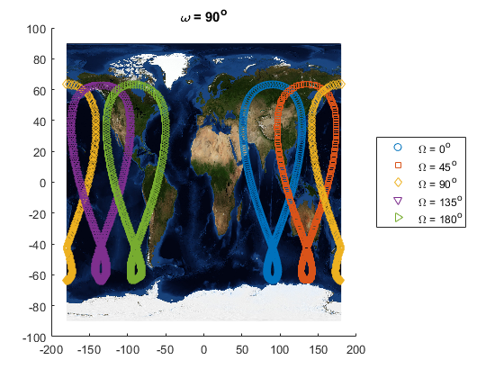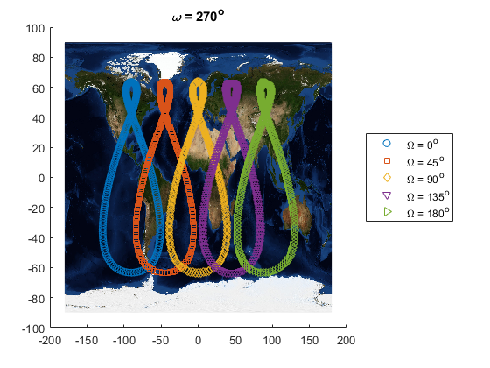

Changing the argument of the periapsis, ω ,rotates the orbit about the angular momentum vector, keeping the same orbital plane

Changing the longitude of the ascending node, Ω ,rotates the orbit about the z vector, which rotates the orbit around the planet

An orbit of ω = 270 and Ω = 0 will spend most of its time over North America

An orbit of ω = 270 and Ω = 180 will spend most of its time over Russia

An orbit of ω = 90 and Ω = 45 will spend most of its time over Australia

An orbit of ω = 90 and Ω = 180 will spend most of its time over South America

A spacecraft with ω = 270 spends most of its time in the northern hemisphere

A spacecraft with ω = 90 spends most of its time in the southern hemisphere

The spacecraft spends 56100 seconds on orbit between crossing point crossings